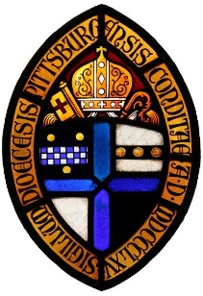
Safe Church, Safe Communities

Image Release Form for Children & Youth

We live in an age of electronic media. Photographs and videos represent a great way for congregations and organizations to record, promote and share church events and activities – especially when they include images of members and their families.
However, we know that not every parent or guardian is comfortable with their child being photographed or filmed, and we want to ensure that the privacy and safety concerns of all are respected. For this reason, we ask those who are willing to allow us to use their child’s likeness to sign the release form below. Naturally, we will not use images for which we do not have written consent.

Release Form
I, _____________________, the legal parent/guardian of __________________________, hereby authorize and consent to the use of images or videos of my child/children by [INSERT NAME OF PARISH OR ORGANIZATION] of [CITY, STATE] for any legal purpose including but not limited to: promotional materials, printed publications, internet posts including social media, and other media sources.
I give this authorization and consent with the understanding that no child’s name will be associated with an image or included in a video recording without my additional express consent.
I sign this form with full knowledge and consent and waive all claims for compensation for use or for damages.
I release [NAME OF PARISH OR ORGANIZATION], its officers, trustees, employees, and agents from liability for any claims by me or any third party in connection with the use of the image of my child/children.
Signature: _______________________________ Date: __________________________

