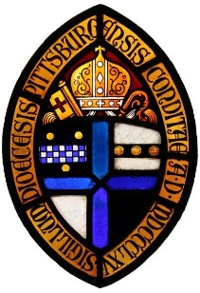
Safe Church, Safe Communities

Image Release Form for Vulnerable Adults

We live in an age of electronic media. Photographs and videos represent a great way for congregations and organizations to record, promote and share church events and activities – especially when they include images of members and their families.
However, we know that not everyone is comfortable being photographed or filmed and we want to ensure that the privacy concerns of all are respected. For this reason, we ask those who are willing to allow us to use their likeness to sign the release form below. Naturally, we will not use images for which we do not have written consent.
Release Form
I, _____________________, hereby authorize and consent to the use of images or videos of myself by [INSERT NAME OF PARISH OR ORGANIZATION] of [CITY, STATE] for any legal purpose including but not limited to: promotional materials, printed publications, internet posts including social media, and other media sources.
I give this authorization and consent with the understanding that my name will not be associated with an image or included in a video recording without my additional express consent.
I sign this form with full knowledge and consent and waive all claims for compensation for use or for damages.
I release [NAME OF PARISH OR ORGANIZATION], its officers, trustees, employees, and agents from liability for any claims by me or any third party in connection with the use of my image.
Signature: ____________________________ Date: __________________________________
*************************************************************************************
( ) Check here and complete the information below if providing consent on behalf of a vulnerable adult who is unable to provide consent themselves due to impairment or lack of agency.
Name: _______________________________ Relationship to the above named: ___________
Signature: ____________________________ Date: __________________________________

